JOIN US TO CELEBRATE THE WORK OF HEADSTART KERNOW

DO YOU WORK WITH YOUNG PEOPLE AGED 10 – 16?
Are you interested in creative opportunities
that will support their wellbeing?

Headstart Kernow, FEAST and Arts Well are pleased to be offering schools and young people’s groups around Cornwall the opportunity to have free creative sessions with local artists. This could be a series of workshops, a one-off masterclass, watching an interactive performance or something else! Sessions will take place between March – July 2022, subject to availability. These creative projects could be a few weekly sessions or take place over a term.

How will it work?
Schools and communities working with young people are invited to register their interest in taking part by completing a short form. We are also in the process of collecting project ideas from artists about the creative activity they’d like to deliver in collaboration with young people. We will then match groups with artists based on the interests of your young people and the artist’s expertise. Please note, we will do our best to provide an artist for all groups that register interest, but there may be cases where this isn’t possible.

When will projects take place?
Projects will take place between March and July 2022, subject to young people’s/artist’s availability. We will contact you after you’ve submitted your form if we are able to propose an artist your young people could collaborate with.

What creative projects are on offer?
We will have a range of artists offering a range of projects. The idea of you completing the form is to find out from your young people about what art forms they’re particularly interested in and where you’re based, so we can match you with a suitable artist. We are asking all artists to send us project ideas that:
- give the young people agency to work on the project idea
- have some connection or visibility in their local community
- help young people to feel more confident, happy, alert, resilient and connected to the world and each other. It is really important that projects will support and nurture the wellbeing of young people.

How do we get involved?
Please complete the attached from to register your interest and send to Izzy@creativekernow.org.uk by Friday 25 February. If you have any questions about the form, Izzy will be happy to talk with you. Just drop her an email or call her on 07821 675 574 – (this number will be active from 10th February).

What happens next?
After you’ve sent us your form, we’ll be in touch to let you know if we have been able to find a suitable artist for your group to collaborate with. If successful, artists will receive training in supporting mental health and wellbeing, including ‘Trauma Informed Practice’, before beginning work with you. We will then put you in contact with the artist to arrange your project dates and it will go from there! Projects will be shaped by the young people together with the artist. We will ask you and the young people to take part in some light touch evaluation as part of being involved. Izzy will be on hand to talk through any questions or thoughts throughout the process.

We look forward to hearing from you!

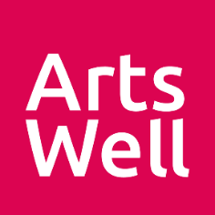
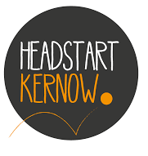
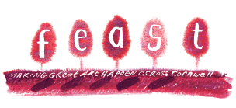
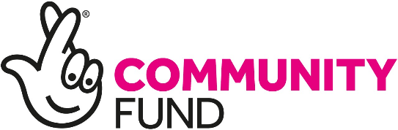
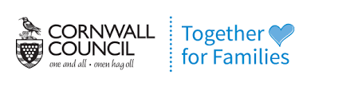
Photo credits (middle and right):
Katharine Leedale

