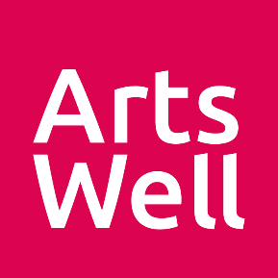
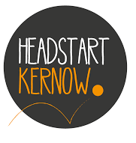
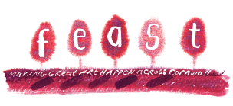

CAN YOUR FEAST PROJECT REACH FURTHER AND INVOLVE
YOUNG PEOPLE?

CALL FOR FEAST ARTISTS TO SUBMIT
CREATIVE PROJECT IDEAS FOR SCHOOLS AND YOUNG PEOPLE’S GROUPS

How could you adapt a FEAST project you have done in the last two years so that it focuses on young people aged 10 – 16 and their wellbeing?
Up to £3k per project available. No match funding necessary.

We are looking for projects that:
- Can take place between March – July 2022
- Give the young people agency to work on the project idea with you
- Have some connection or visibility in their local community
- Can help young people to feel more confident, happy, alert, resilient and connected to the world and each other

All artists will be expected to attend a training session with Headstart Kernow and Arts Well in ‘5 Ways to Wellbeing’ and ‘Trauma Informed Practice’.

Tell us about your project idea by completing the form below. We want the young people to consider your proposal and then help shape the detail of the project so you must be prepared to be flexible and responsive! Please note, we are being led by the young people about the kinds of creative experiences they want, so unfortunately we cannot guarantee that your idea will be selected.

If you want to talk your application through, Izzy will be happy to discuss – Izzy@creativekernow.org.uk / 07821 675 574 (active from 10th Feb)

This is a partnership between FEAST, Headstart Kernow and Arts Well.
FEAST is part of Ceative Kernow charity no.292138
ABOUT YOU
Your name
Your contact details | Email |  | Tel
Organisation (if applicable)
Your role
Address
Your artform/s
Where would you be willing to deliver activity? Please list area names if outside of your locality.
YOUR PROJECT
What is the FEAST project that you have run? How do you feel this project could be adapted for this programme working with young people?
Please describe your project idea, including the number of sessions you’d like to run, ideal participant numbers, and in which period you would want to deliver.
In which part of Cornwall would you ideally want to work?
Please tell us how your project idea will support young people with at least one of the 5 Ways to Wellbeing

1) connect 2) be active 3) take notice 4) keep learning 5) give
Please tell us about your experience of working with young people.

Please tell us about age groups you have worked with and settings (e.g. school, youth club) that you have worked in.
Please tell us about any skills or experience you have working with young people who have additional needs and/or mental health challenges
If you will be collaborating with any artists who are new to FEAST, please tell us more about them and provide evidence of their experience or links to their work if possible
How will you ensure that young people have agency over the project and are able to shape their involvement?
You are legally responsible for your project. How will you ensure that young people and the general public are safe?
How will your project connect with and be visible within the local community?
How much are you asking us for? (Up to £3,000). Please provide a budget breakdown below. (Match funding is not required.)
Please tick all that apply | ⬜ I have a DBS certificate  ⬜ I am willing to attend training with Headstart Kernow and Arts Well (you will be paid to attend this training)  ⬜ I am available to deliver this work between March and July 2022  ⬜ I have Public Liability Insurance to a minimum of £5,000,000
Thanks for the info!

Please send your form to izzy@creativekernow.org.uk as soon as possible. We’ll be in touch soon after you’ve submitted to let you know the outcome. We will be looking through applications on a rolling basis but will be closing applications on 31 March 2022.

Budget breakdown (add/delete rows as needed)
Please include costs for travel, venue and materials (if applicable), day rate and number of sessions offered.
Expenditure
Item or activity | Cost
TOTAL

