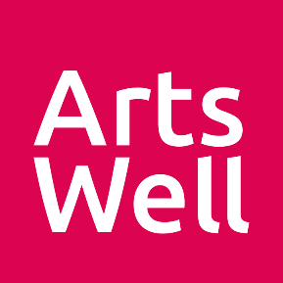
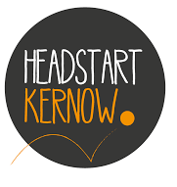
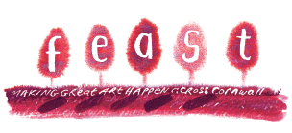

CALL OUT FOR ARTISTS TO SUBMIT CREATIVE PROJECT IDEAS FOR SCHOOLS AND
YOUNG PEOPLE’S GROUPS

We are excited to be offering young people aged 10 - 16 around Cornwall the opportunity to take part in free creative programmes with local artists. This could be a series of workshops, a one-off masterclass, an interactive performance
or something else!

We are looking for projects that:
- Can take place between March – July 2022
- Give the young people agency to work on the project idea with you
- Have some connection or visibility in their local community
- Can help young people to feel more confident, happy, alert, resilient and connected to the world and each other

Up to £3k per project available. No match funding required.

All artists will be expected to attend a training session with Headstart Kernow and Arts Well in ‘5 Ways to Wellbeing’ and ‘Trauma Informed Practice’.

To apply to be an artist on this programme, please tell us your project idea by completing the form below. We want the young people to consider your proposal and then help shape the detail of the project so you must be prepared to be flexible and responsive! Please note, we are being led by the young people about the kinds of creative experiences they want, so unfortunately we cannot guarantee that your idea will be selected.

If you want to talk your application through, Izzy will be happy to discuss – Izzy@creativekernow.org.uk / 07821 675 574 (active from 10th Feb)

This is a partnership between FEAST, Headstart Kernow and Arts Well.
FEAST is part of Ceative Kernow charity no.292138
ABOUT YOU
Your name
Your contact details | Email |  | Tel
Organisation (if applicable)
Your role
Address
Your artform/s
Where would you be willing to deliver activity? Please list area names if outside of your locality.
Please tick all that apply  (This information will not affect the success of your application) | ⬜ I have applied to FEAST for funding before  ⬜ I have never received any form of arts funding from FEAST before
YOUR PROJECT
Please describe your project idea, including the number of sessions you’d like to run, ideal participant numbers, and in which period you would want to deliver.
In which part of Cornwall would you ideally want to work?
Please tell us how your project idea will support young people with at least one of the 5 Ways to Wellbeing

1) connect 2) be active 3) take notice 4) keep learning 5) give
Please tell us about your experience of working with young people.

Please tell us about age groups you have worked with and settings (e.g. school, youth club) that you have worked in.
Please tell us about any skills or experience you have working with young people who have additional needs and/or mental health challenges
Please provide evidence of your experience or links to your work (if possible) plus any other artists you plan to collaborate with on your project
How will you ensure that young people have agency over the project and are able to shape their involvement?
You are legally responsible for your project. How will you ensure that young people and the general public are safe?
How will your project connect with and be visible within the local community?
How much are you asking us for? (Up to £3,000) Please provide a budget breakdown below. (Match funding is not required.)
Please send us contact details for one reference.
Please tick all that apply  (This information will not affect the success of your application) | ⬜ I have a DBS certificate  ⬜ I am willing to attend training with Headstart and Arts Well] (You will be paid to attend this training)  ⬜ I am available to deliver this work between March and July 2022  ⬜ I have Public Liability Insurance to a minimum of £5,000,000
Thanks for the info!

Please send your form to izzy@creativekernow.org.uk as soon as possible. We’ll be in touch soon after you’ve submitted to let you know the outcome. We will be looking through applications on a rolling basis but will be closing applications on 31 March 2022.

Budget breakdown (add/delete rows as needed)
Please include costs for travel, venue and materials (if applicable), day rate and number of sessions offered.
Expenditure
Item or activity | Cost
TOTAL

